INDEX

|  |  |  |
| --- | --- | --- |
| LAB NO | Content | Page |
| 01 | Assemble different parts of a computer | 3-6 |
|  |  |  |
|  |  |  |
|  |  |  |
|  |  |  |
|  |  |  |

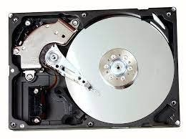**Lab: 1**

**Assembling different parts of a computer:**

1. **Hard disk drive:**

A hard disk drive (HDD) is a data storage device used for storing and retrieving digital information using rapidly rotating disks (platters) coated with magnetic material. Data is written and read from the disks using magnetic heads positioned on moving arms. HDDs are commonly found in computers, laptops, and servers for long-term data storage.

1. **CPU (Central Processing Unit):**

The CPU is the central component responsible for processing data and executing instructions. It acts as the "brain" of the computer, performing calculations and managing tasks required by software programs. The CPU interprets commands from memory and controls data flow within the system.

1. **Motherboard:**

The motherboard is the main circuit board in a computer that connects and allows communication between all other components, such as the CPU, memory, storage devices, and input/output peripherals. It provides slots for various components and serves as a platform for data exchange.

**Hard disk drive**

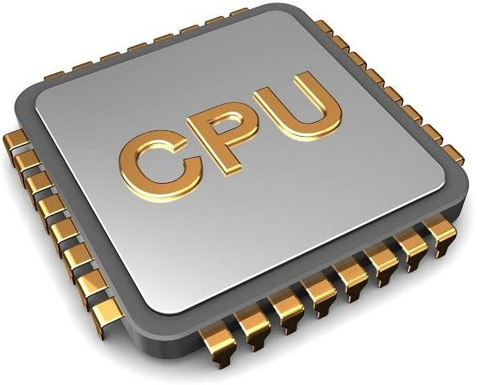

**CPU**

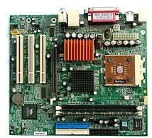

**Motherboard**

1. **RAM (Random Access Memory) / ROM (Read-Only Memory):**

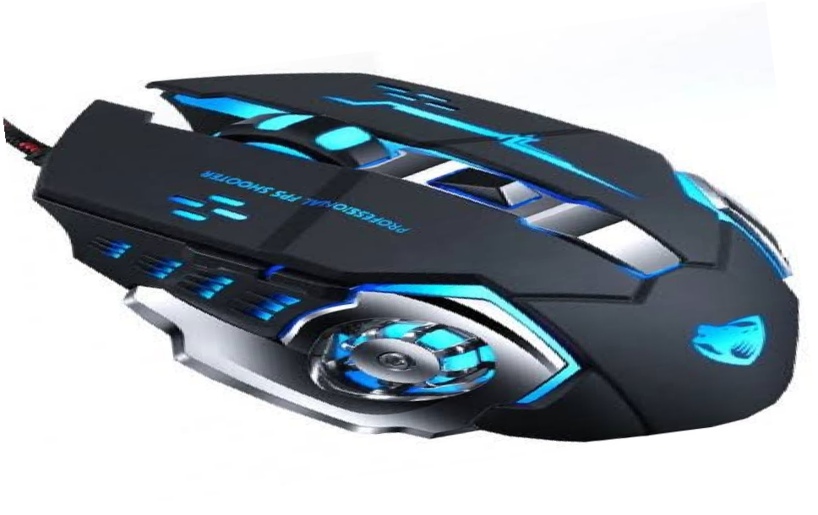

**Mouse**

RAM is a volatile memory used to temporarily store data and instructions that the CPU needs to access quickly. It is essential for running programs and multitasking. ROM is a non-volatile memory that contains permanent data, typically the computer's firmware or BIOS, which helps initialise hardware during startup.

1. **CD/DVD (Optical Disc Drives):**

CD and DVD drives are optical storage devices that read and write data from discs using a laser. CDs and DVDs are used to store software, media files, and backups, although they are less common today due to USB drives and cloud storage.

1. **Keyboard:**

The keyboard is an input device that allows users to enter text, commands, and data into the computer. It consists of keys for letters, numbers, and functions, enabling interaction with software applications.

1. **Mouse:**

The mouse is a pointing device that allows users to interact with the graphical user interface (GUI) by moving the cursor and clicking on elements. It enables easy navigation and control within software environments.

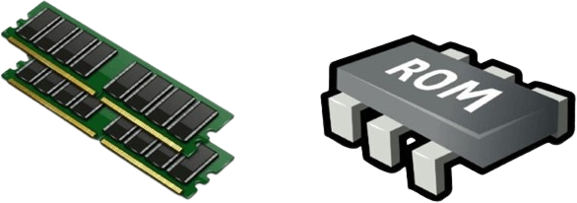

**RAM & ROM**

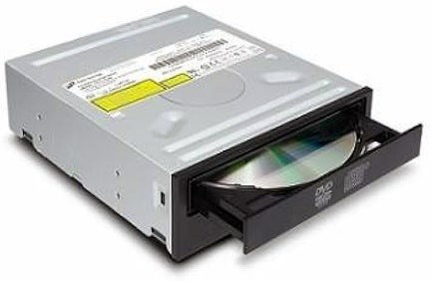

**DVD**

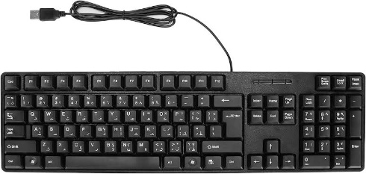

**Keyboard**

1. **SATA Cable:**

SATA (Serial ATA) cables are used to connect storage devices, like hard drives and SSDs, to the motherboard for data transfer. These cables are crucial for the proper functioning of internal storage systems.

1. **USB Port:**

A USB (Universal Serial Bus) port allows external devices such as flash drives, printers, and cameras to connect to the computer for data exchange and power supply. USB is widely used for connecting peripherals.

1. **Input Device:**

Input devices are hardware that allow users to provide data and commands to the computer, such as keyboards, mice, scanners, and microphones. They enable interaction between the user and the computer system.

1. **Output Device:**

Output devices allow the computer to communicate information back to the user. Examples include monitors, printers, and speakers. These devices display data, print documents, or produce sound.

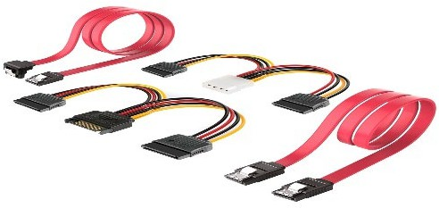

**SATA Cable**

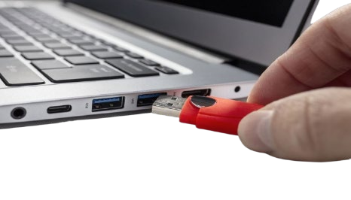

**USB Port**

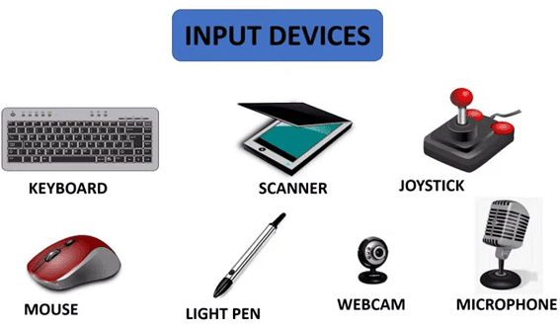

**Input device**

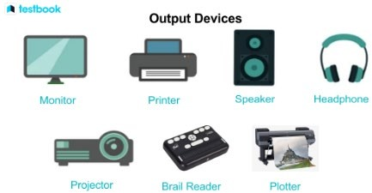

**Output device**

1. **Heat Sink:**

A heat sink is a passive cooling device attached to the CPU or other components to dissipate heat generated during operation. It helps maintain optimal temperature levels by transferring heat away from the processor.

1. **Power Supply:**

The power supply unit (PSU) converts electrical energy from the outlet into usable power for the internal components of the computer. It provides the necessary voltage and current to run the system.

1. **Cooling Fan:**

Cooling fans are used to regulate the temperature inside the computer by circulating air and preventing overheating. They work alongside heat sinks and are essential for maintaining the stability and performance of components.

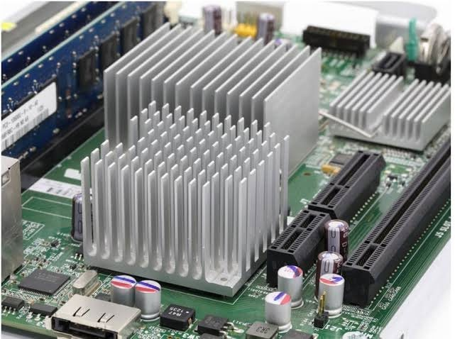

**Heat sink**

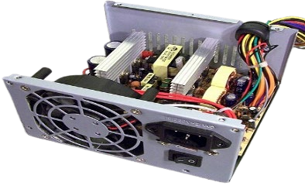

**Power supply**

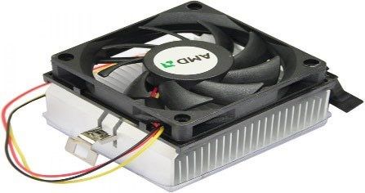

**Cooling fan**